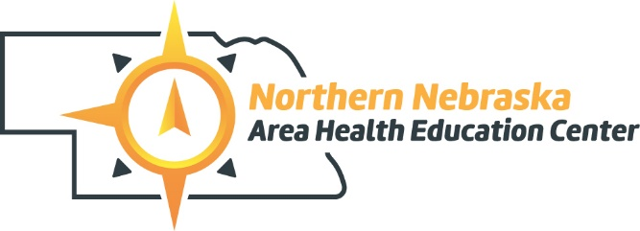
110 No. 16th Street, Suite #2 ● Norfolk, NE 68701
Voice: (402) 644-7253 ● Fax: (402) 644-7254 ● www.nnahec.org

October 21, 2020
Health Careers Club member,

We are planning another exciting year of exploring healthcare professions through hands-on experiences, guided tours, guest speakers, insightful discussions and we’re inviting YOU along for all the fun! As you already know, the Health Careers Club provides a valuable opportunity to network with health professionals, to make new friends, and to participate in volunteer and community events.

2020 has made all of us make changes, including Health Careers Club. Health Careers Club will be moving to a virtual format. We will utilize Zoom for our virtual platform and have health care professionals showcase their profession and then do a case study, provide tours, etc. Our meetings will be 90 minutes long and we may record some based on student interest.

Health Careers Kick-off:
Cover Multiple Health Careers with the Staff from Hetiage of Bel-Air
7-8:30 p.m., Wednesday, October 28
Location will be virtual! Register on Zoom: https://bit.ly/310UDqQ
or scan the code with your phone’s camera

Friends and parents welcome to attend.
Please mail $20 to the address above for dues.

After this initial meeting, the Health Careers Club will be meeting on November 18, December 9, January 27, February 24, March 24, and April 28. from 7 to 8:30 p.m. Check out our Facebook and Twitter pages for updated information about each month’s featured health career. We will continue to send you a postcard each month with all the details. You can also check out the poster in your school!
Northern Nebraska  AHEC Health Careers Club | @HealthCareersNE

We look forward to you attending and learning more about the exciting opportunities that exist in the world of healthcare. If you have any questions please feel free to contact us.

Sincerely,

Gretchen Forsell MPH, RD, LMNT Alyssa Johnson, BS
Executive Director Program Coordinator
gforsell@nnahec.org ajohnson@nnahec.org

